# **Java main() Method:**

# **public static void main(String[] args)**

**Java’s main() method** is the starting point from where the **JVM** starts the execution of a Java program. JVM will not execute the code, if the program is missing the main method. Hence, it is one of the most important methods of Java, and having a proper understanding of it is very important.

The Java compiler or JVM looks for the main method when it starts executing a Java program. The signature of the main method needs to be in a specific way for the JVM to recognize that method as its entry point. If we change the signature of the method, the program compiles but does not execute.

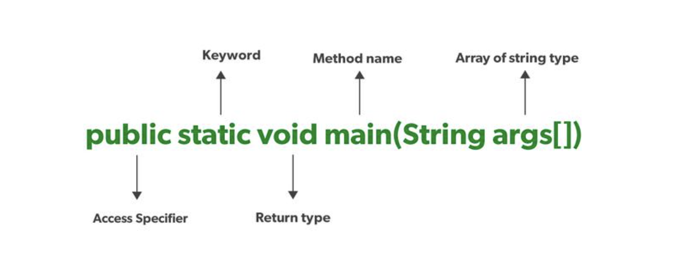

### **1. Public**

It is an **Access modifier**, which specifies from where and who can access the method. Making the main() method public makes it globally available. It is made public so that JVM can invoke it from outside the class as it is not present in the current class.

If the main method is not public, its access is restricted.

### **2. Static**

It is a **keyword**that is associated with a method, making it a **class-related method**. The *main()* method is static so that JVM can invoke it without **instantiating the class**. This also saves the unnecessary wastage of memory which would have been used by the object declared only for calling the *main()* method by the JVM.

If you try to run Java code where main is not static, you will get an error.

### **3. Void**

It is a **keyword** and is used to **specify that a method doesn’t return anything**. As the *main()* method doesn’t return anything, its return type is **void**. As soon as the *main()* method terminates, the Java program terminates too. Hence, it doesn’t make any sense to return from the *main()* method as JVM can’t do anything with its return value.

If the main method is not void, we will get an error.

### **4. main**

It is the **name of the Java main method**. It is the **identifier** that the JVM looks for as the **starting point of the Java program**. It’s not a keyword.

If we change the name while initiating the main method, we will get an error.

### **5. String[] args**

It **stores Java command-linearguments** and is an array of type ***java.lang.String*** class. Here, the name of the String array is *args* but it is not fixed and the user can use any name in place of it.

Java main() method is the starting point of a Java program. It is the main body that is executed by the JVM, and without the main() method no Java program can be run without it.